CURRICULUM VITAE
1 | Full Name | Dewi Syafitri | 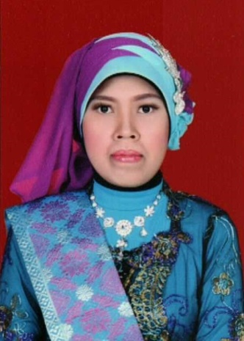
2 | Place/ Date of Birth | Jambi, 6 December 1987
3 | Sex | Female
4 | Religion | Moslem
5 | Email | syafitri77@gmail.com
6 | Address | JLN. TP. Sriwijaya No. 13 RT. 04 RW. 01 Kel. Beliung Kec. Kotabaru Jambi Zip Code 36125
7 | S1 | Universitas Jambi
8 | S2 | Universitas Sriwijaya

